

**Time Box App**

**V 2.2.0.0**

**USER GUIDE**

February 2020

Table of Contents

1. LOGIN 4

2. PLANNING 6

2.1 Create planning 6

2.1.1 Search by work item 7

2.1.2 Search by project 8

2.2 Task information 11

2.3 Add a Draft 12

3. DAILY 15

3.1 Select Users 16

4. TIME EXPLORER 18

4.1 Edit Time 19

4.2 Delete Time 19

4.3 Add Time 19

5. WEEKLY 22

5.1 Select Users 22

6. WORKLOGS 25

6.1 Set date criteria 25

6.2 Set source criteria 27

6.3 Generate worklogs report 28

# LOGIN

To access the app, the user should go to:<https://nserio-mishoras.azurewebsites.net/login>, and then click on **Sign in With Microsoft** option.

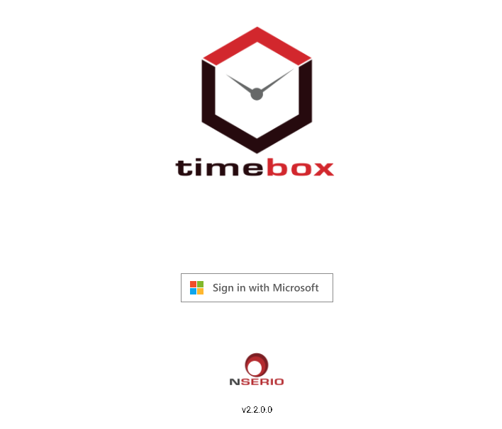

The application redirects the user to login with the Microsoft credentials.

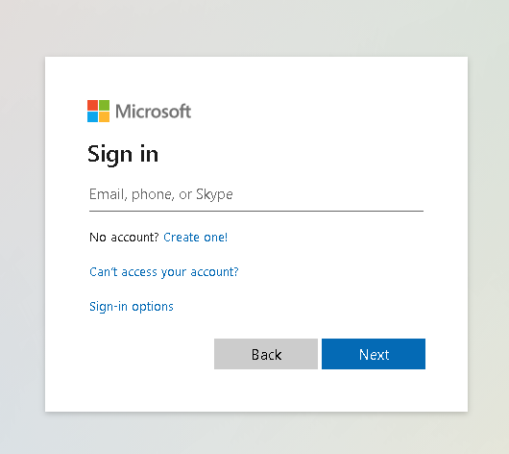

**Note:** If you have Microsoft Authenticator App configured, you will be asked for an approval on your mobile device.

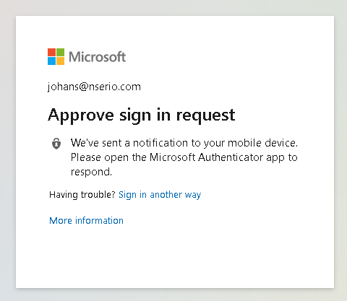

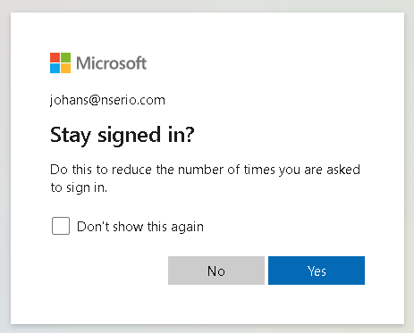

# PLANNING

After successful login, user will be redirected to the **Planning** screen.

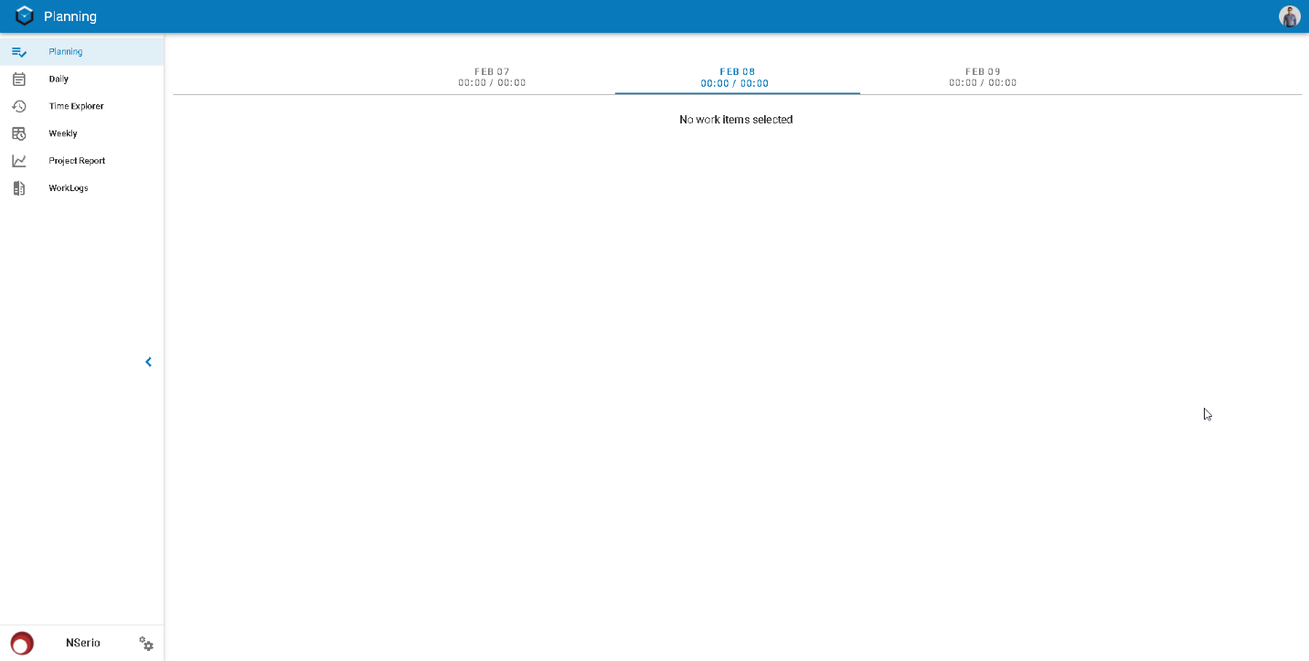

In this section the user will be able to create the plan and view the work items to work for the specified day.

## 2.1 Create planning

The user is able to plan his/her day and to do that he could add tasks to log the time in:

1. Click on  button.
2. Click on “Add Work Item”.

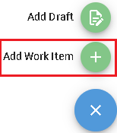

1. The advance search option is displayed, the suggested work items for the user will be displayed, however user can either search **By Project** or **By Work Item**.

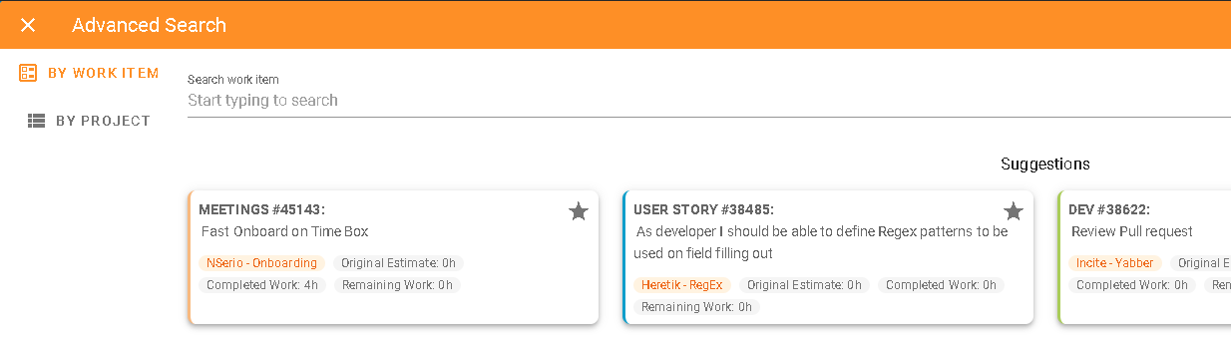

### **Search by work item**

1. In the **By Work Item** option, type the name or the ID for the work item that user wants to be added to the planning.

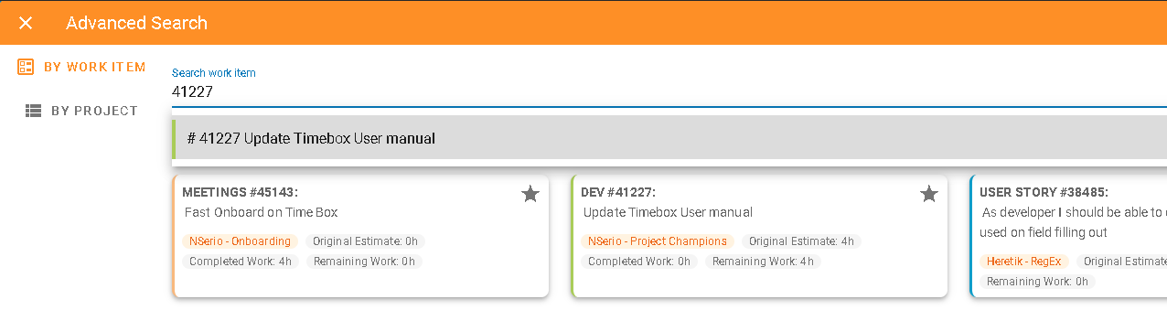

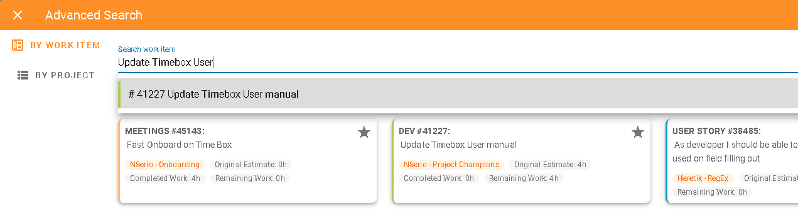

1. Choose the work items to work on by clicking on each of them, they will grey out when they are selected. User can select multiple items.

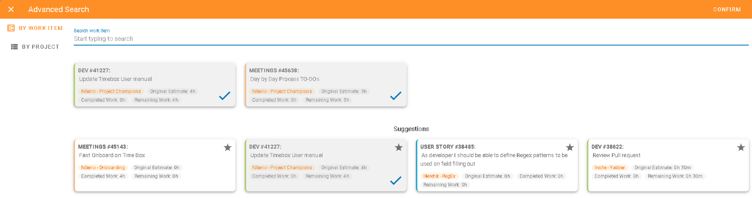

1. Click on **Confirm** button, on the top right part of the screen to add the selected work items to the date planning.

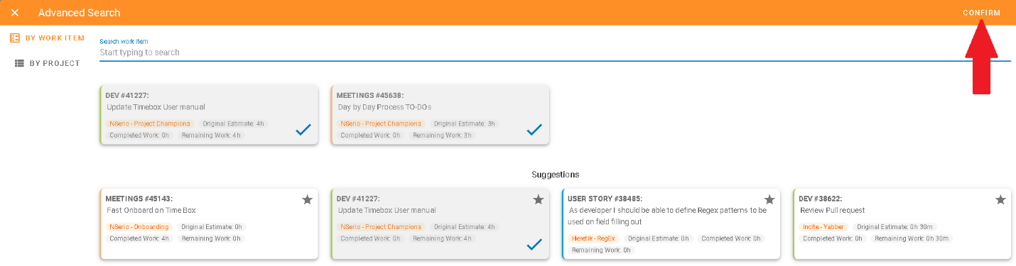

The selected tasks will be added to the planning for the specified date.

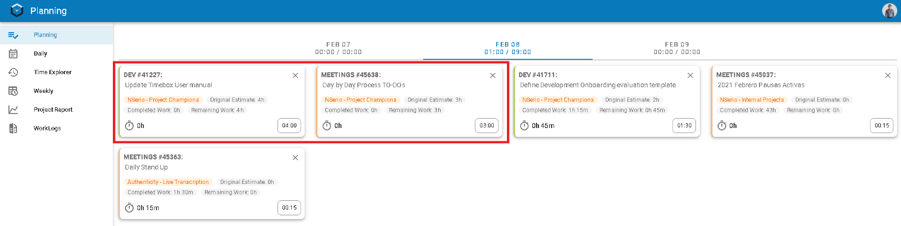

### **Search by project**

1. In the **Advance Search** screen, click on the **By Project** option.
2. Look for your project, by typing the name of the project on the search bar.

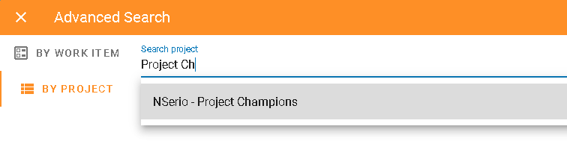

1. All the work item types available in the project will be displayed.

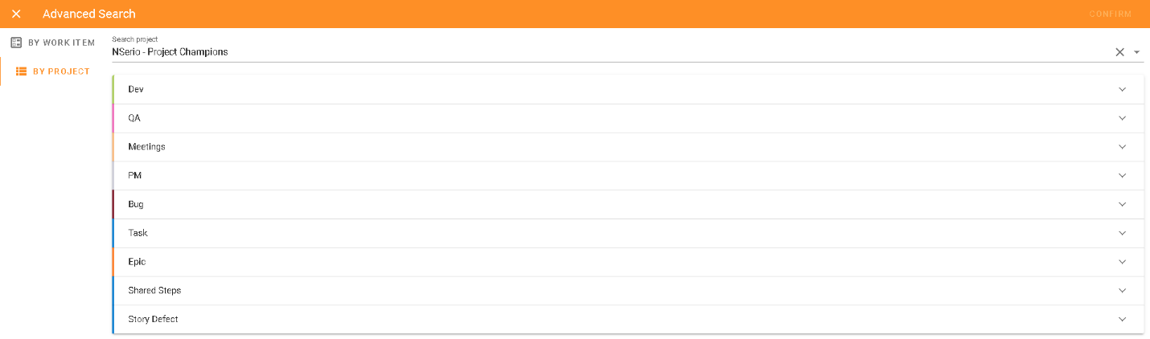

1. Click on the type of task, Time Box will show the top 10 recently updated work items of the selected type. User can see the next 10 items by clicking on the “>” option

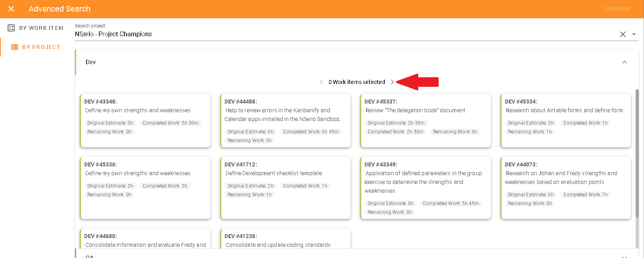

1. Choose the work items you want to add to the planning by clicking on them, they will be highlighted on grey and a blue approval mark will be shown at right bottom corner.

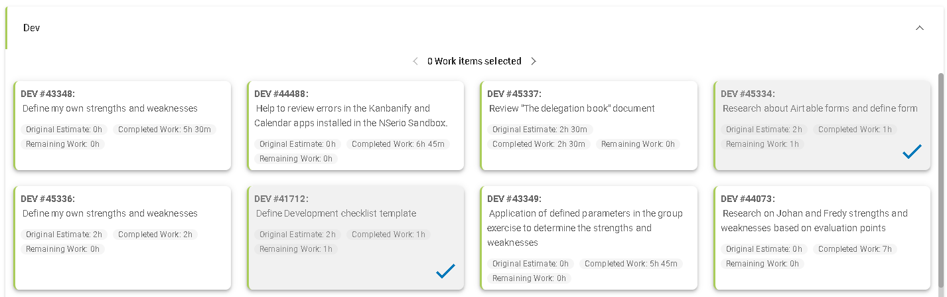

1. Click on **CONFIRM** button.

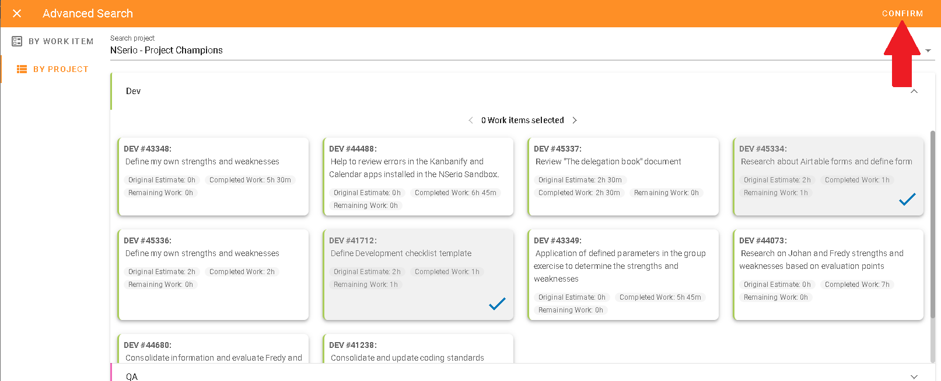

The selected work items will be added to the planning.

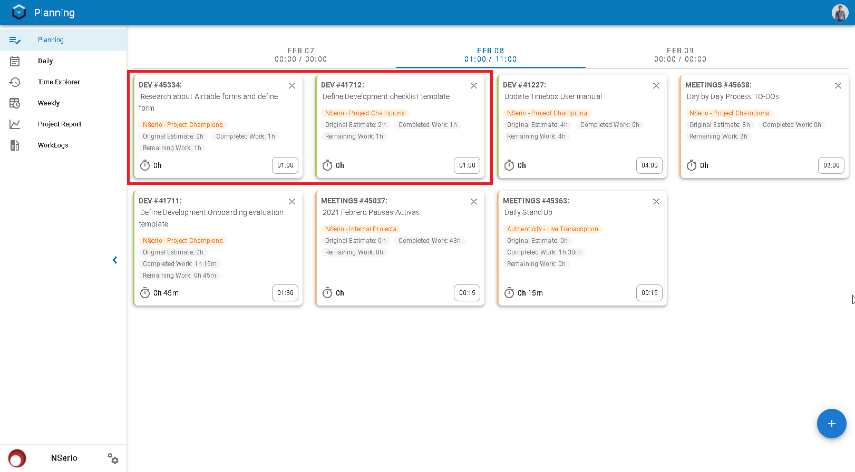

## 2.2 Task information

There is a lot of valuable information in each of the work item cards that can be very useful for each user:

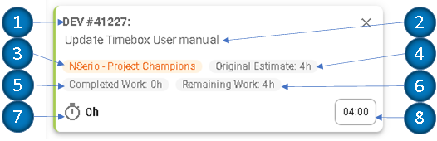

1. Work Item ID
2. Work Item Name
3. Project Name
4. Original Estimate (if the item does not have this field filled out, the value will be 0)
5. Completed Work
6. Total Remaining work
7. Total time logged on the task (when the user logs time, this value will be updated)
8. Planned time to work on the item (the user should update this value)

## 2.3 Add a Draft

After adding the planned work items for the day planning, it still might be unexpected tasks or items that are not for sure yet, they can still be planned for the day and saved as work items in a later time. This is what the drafts are created for.

1. Click on  button.
2. Click on “Add Draft”.

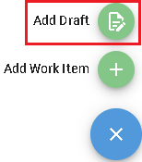

1. A new **Add Draft** modal will be opened.

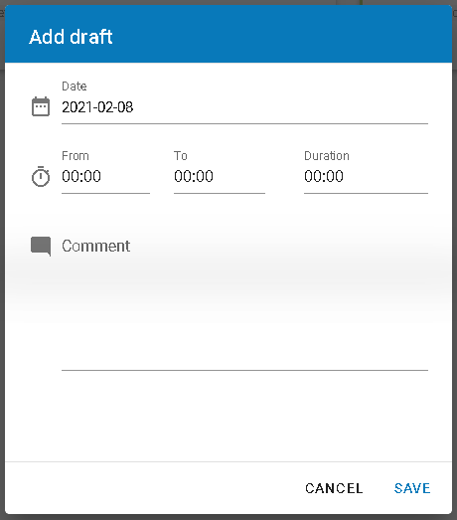

1. Add the **Duration** of the time log or you can also set the **From** and **To** fields, they indicate the start and end hours, then the Duration will be calculated.

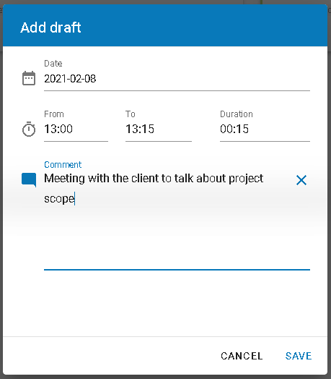

1. Click **SAVE** to create the Draft.

Draft will be added to the daily planning.

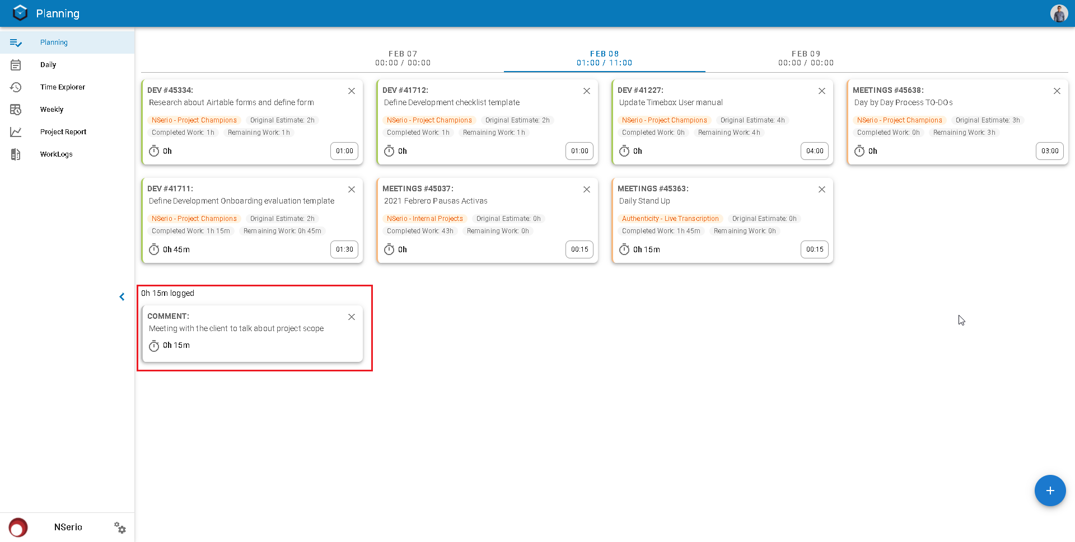

The user will only be able to create drafts along the same day, after midnight user will not be able to create another draft for the past day.

To save a draft as a time log, user will need to edit the draft first:

1. Click on the **Draft** to be converted, the Edit Draft modal will be opened.

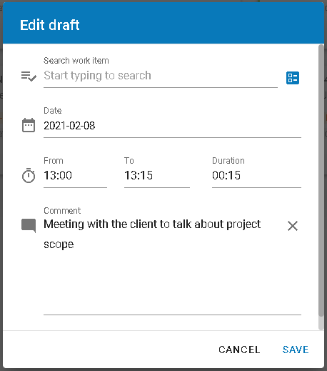

1. The user must set the **Work Item**, this can be done searching the work item by ID or Name on the search bar, or user can also search the work item based on the project it belongs to, by clicking on the **Search By Project** icon  at the right of the search bar.

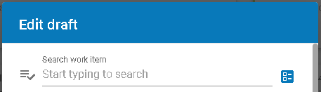

1. Validate the time log **Duration** andedit if necessary.
2. Validate the **Comment** andedit if necessary.

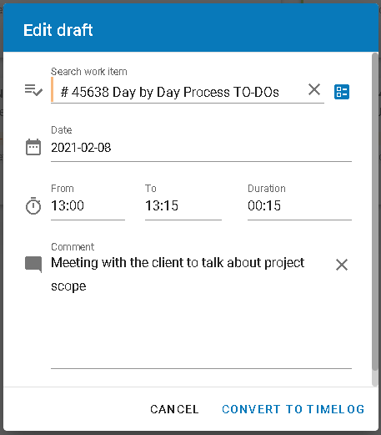

1. Click on **CONVERT TO TIMELOG** to save as time log for the day.

# DAILY

In this menu option, the users will be able to view the planning sheets created by himself/herself or any other users for each day. This daily will be updated accordingly to the planning, so the users will be able to view not only the time logged but also the work items that were planned for a date.

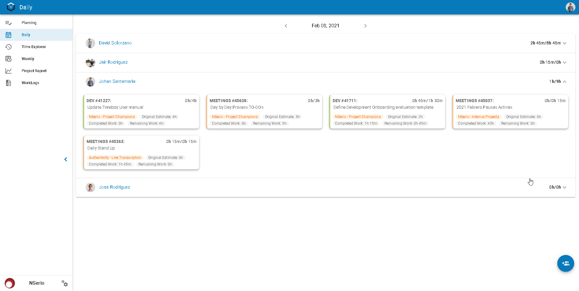

The work right ther have new information on the top right corner, it shows the information about **Time Logged / Time Planned**.

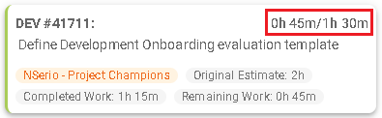

The above scenario shows that there were 1.5 hours (1 hour and 30 minutes) planned for the work item and the user already logged 0.75 hours (45 minutes), so it displays 0h 45m/1h 30m.

The daily menu option allows the user to view his own daily sheets or he/she can also see other team member’s sheets. To do that, the user will need to configure the teammates.

## 3.1 Select Users

1. Click on  option.
2. The **Add Members** modal is displayed, so the user is able to select the teammates and add them to the daily dashboard.

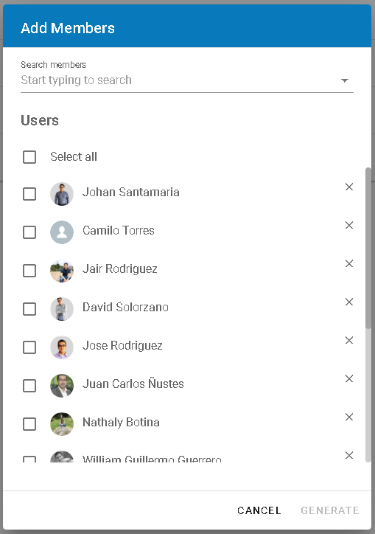

1. In case that the user wanted to add a member that is not listed, will be able to search by the name for the team member.

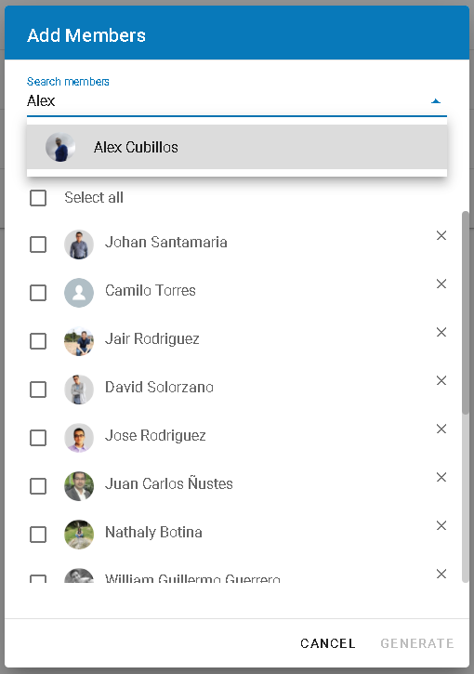

1. Select the team member to be added to the daily sheet and click on **GENERATE**.

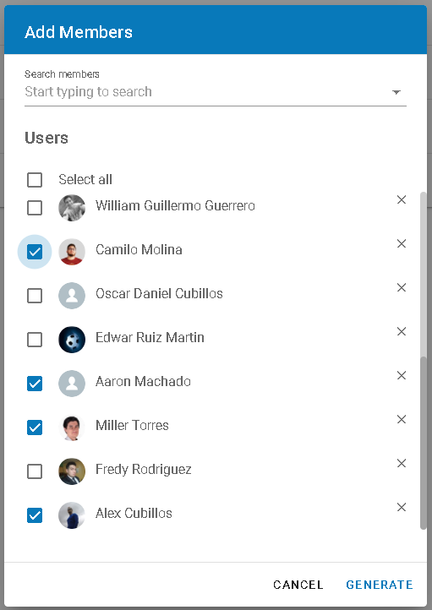

All selected team members will be added to the Daily dashboard and the user will be able to navigate through other dates using the date navigation buttons “**<**” and “**>**”.

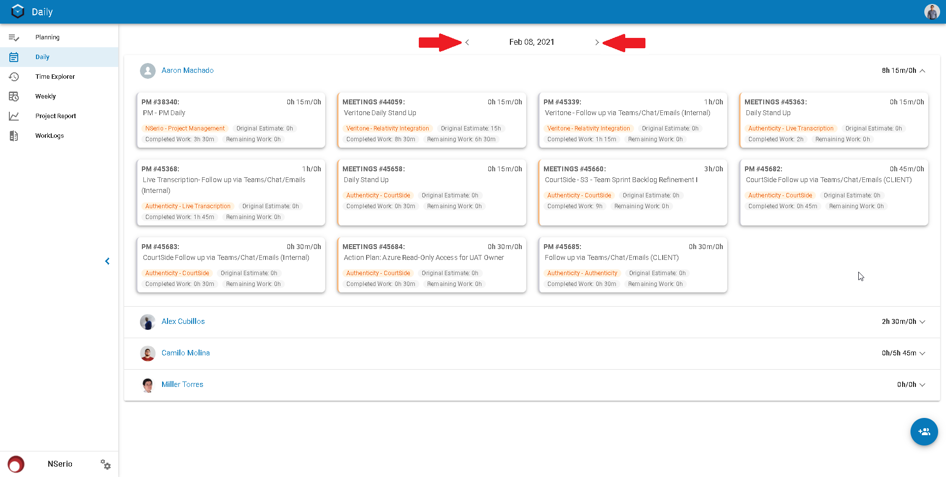

# TIME EXPLORER

In this menu option the user will be able to view the time he/she has logged in a month.

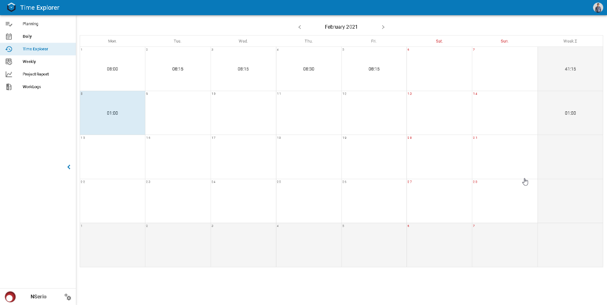

When the user clicks on a day, he/she will be able to see the day detail, including the number of hours logged and what were the work items.

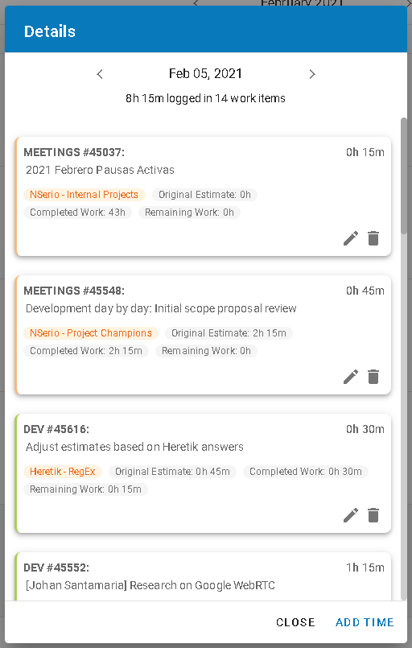

Right there, the user will be able to Edit and Delete the existing time logs for the day.

## 4.1 Edit Time

Clicking the **Edit** button , the user will be able to edit the logged entry. The **Duration**, **From**, **To** and **Comment** fields can be updated. The changes will be applied until the user clicks on the **SAVE** button.

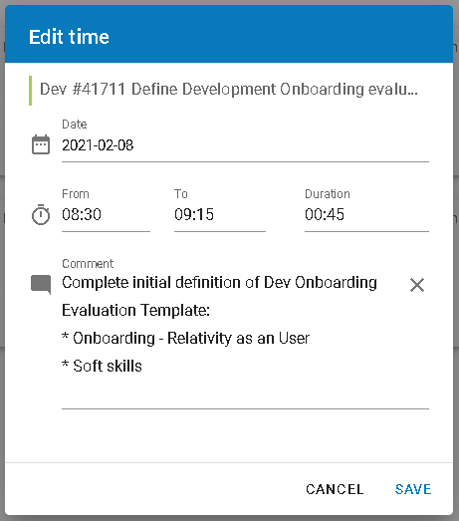

## 4.2 Delete Time

Clicking the **Delete** button , the user will be able to delete the logged entry. Time Box will show a confirmation modal, then the user can confirm the action clicking on **OK**.

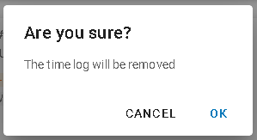

## 4.3 Add Time

At the bottom of the day detail modal, there is a button with the text **ADD TTIME**, this option allows the user to create a new time log entry for the day.

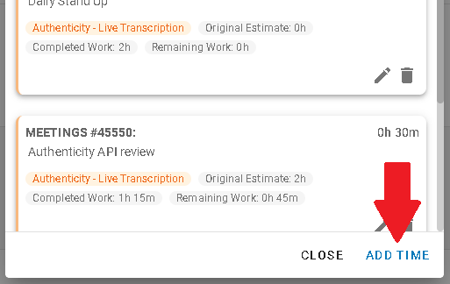

Once the user clicks on that option, the Add time modal will be shown, not that you could save it as a draft as well.

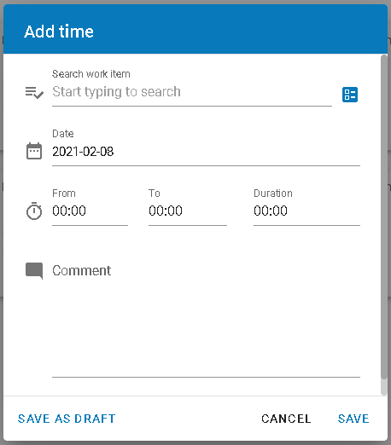

1. The user must set the **Work Item**, this can be done searching the work item by ID or Name on the search bar, or user can also search the work item based on the project it belongs to, by clicking on the **Search By Project** icon  at the right of the search bar.



1. Set the time log **Duration** (you can calculate it using the **From** and **To** values).
2. Set the **Comment** field with a descriptive value.

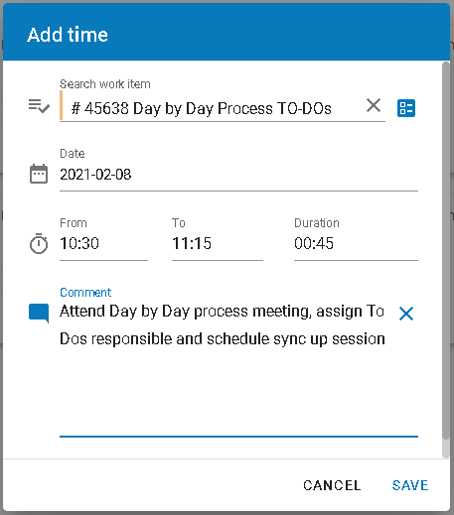

1. Click **SAVE**.

The time log has been created and the details modal is updated.

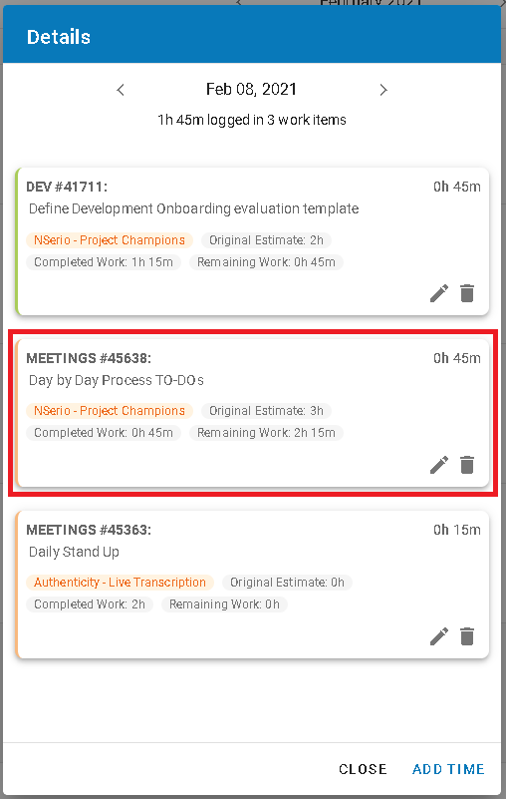

After clicking the **CLOSE** button, user will be able to see the day log has been updated as well in the month view.

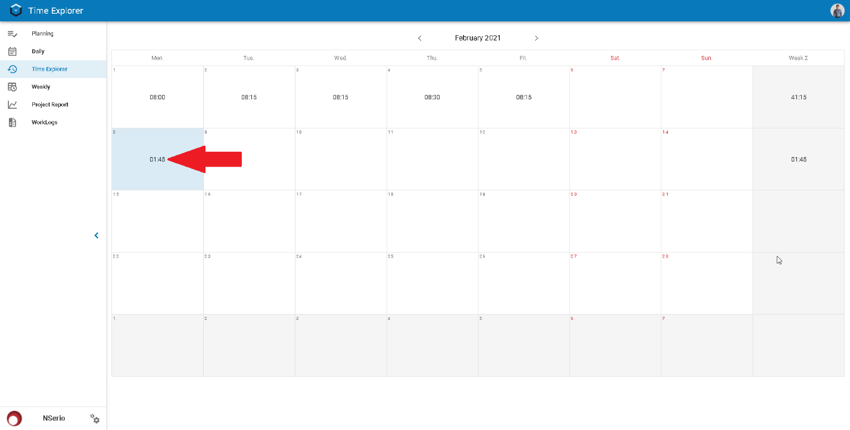

# WEEKLY

This menu option provides the ability to view the logged time by week, likewise the daily option, the user is able to see his/her logged times and the logged times of his/her teammates.

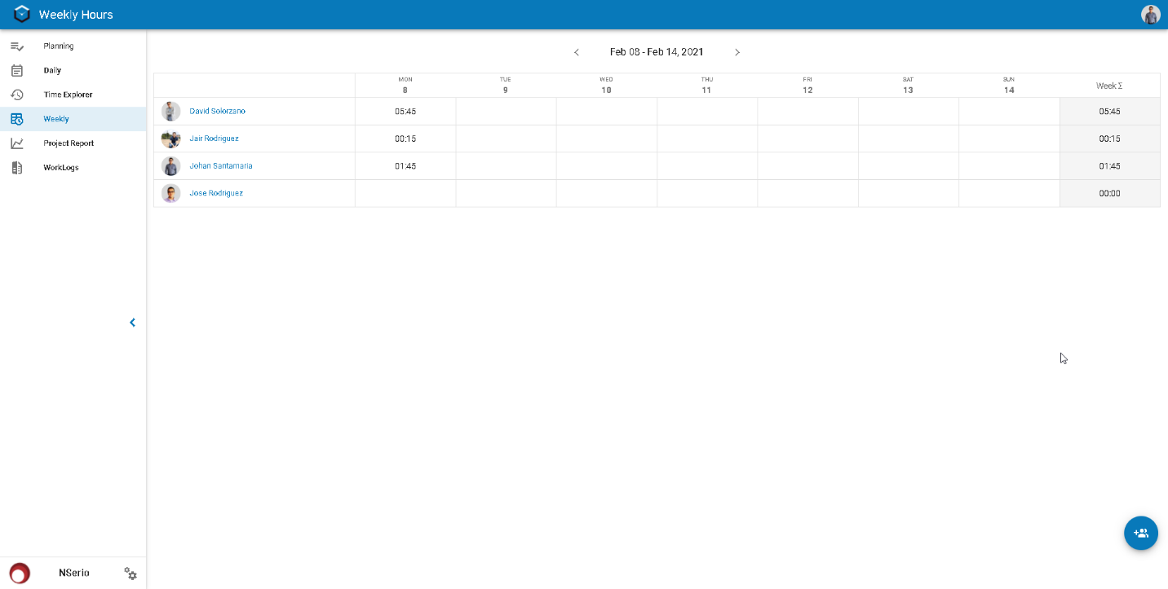

## 5.1 Select Users

1. Click on  option.
2. The **Add Members** modal is displayed, so the user can select the teammates he/she want to add to the weekly dashboard.

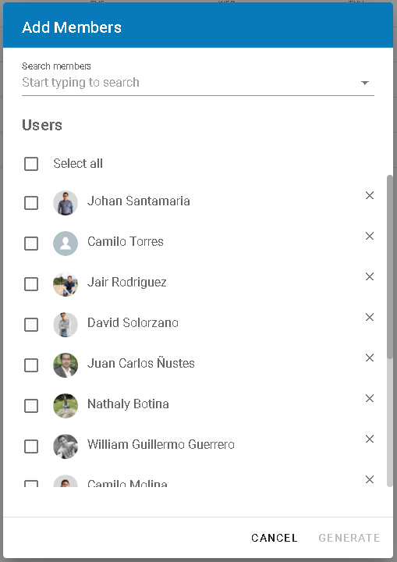

1. In case that the user wanted to add a member that is not listed, will be able to search by the name for the team member.

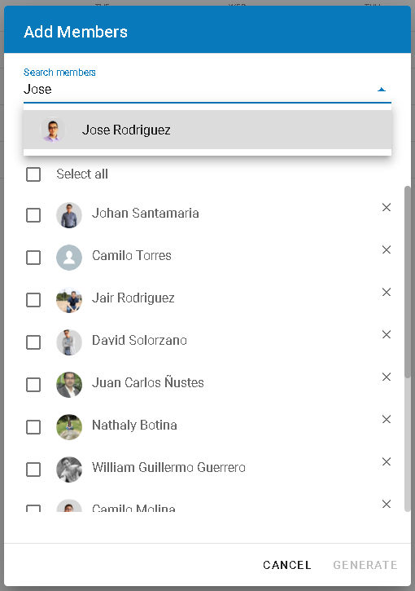

1. Select the team member to be added to the daily sheet and click on **GENERATE**.

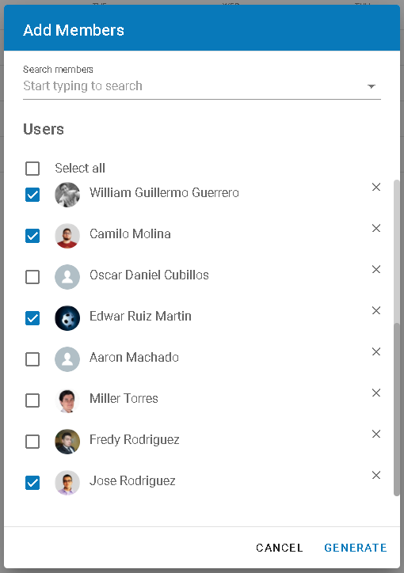

All selected team members will be added to the **Weekly Hours** view and the user will be able to navigate through other weeks by using the navigation buttons “**<**” and “**>**”.

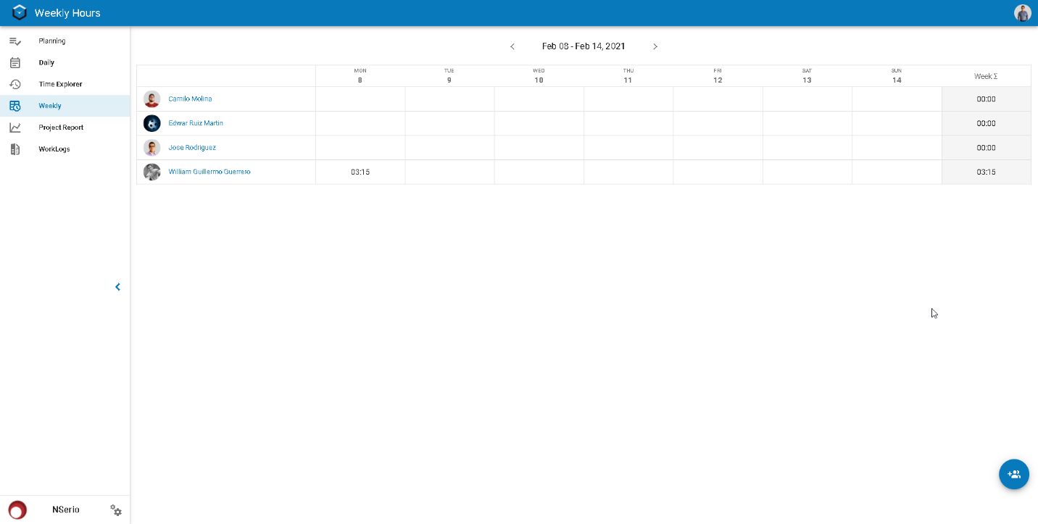

# WORKLOGS

This menu option provides a helpful tool to download logged time entries based on time and source provider criteria.

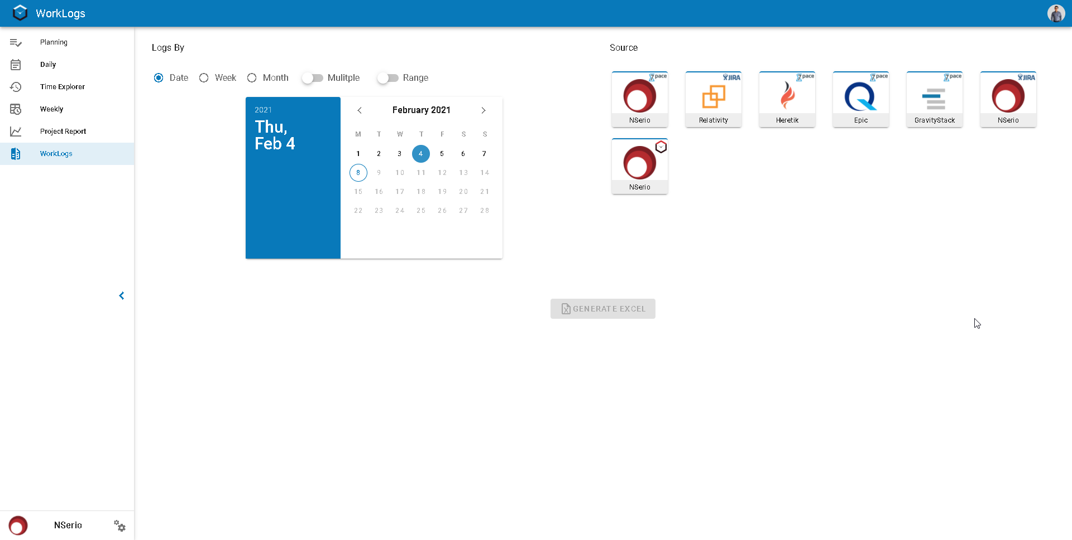

## Set date criteria

The user is able to set the date search criteria in different ways:

* Single day

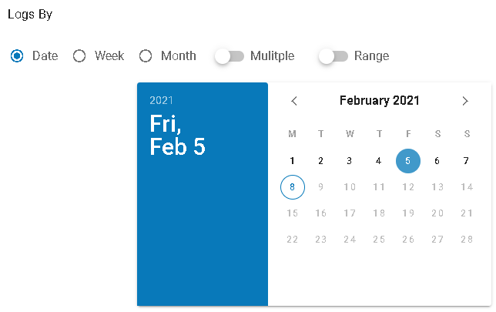

* Multiple days

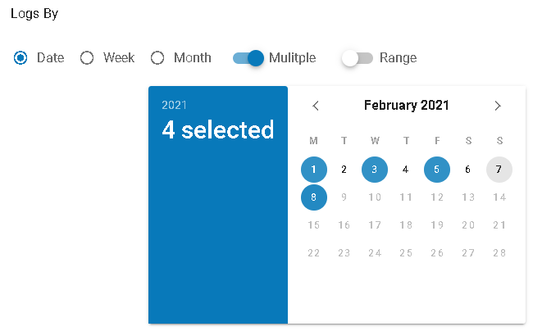

* Date range

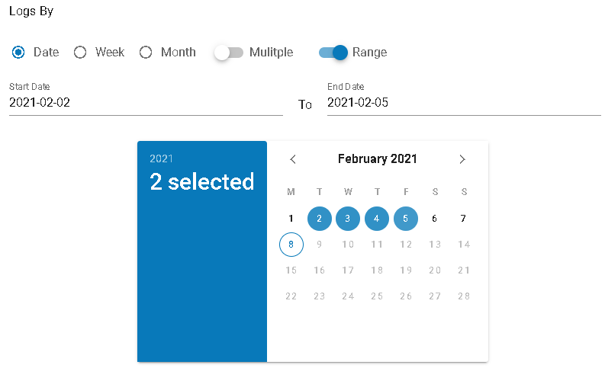

* Single week

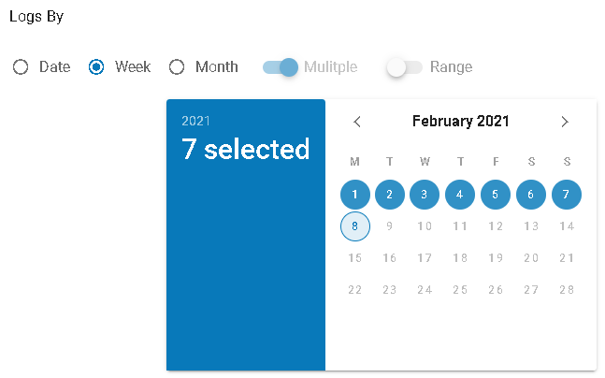

* Multiple weeks

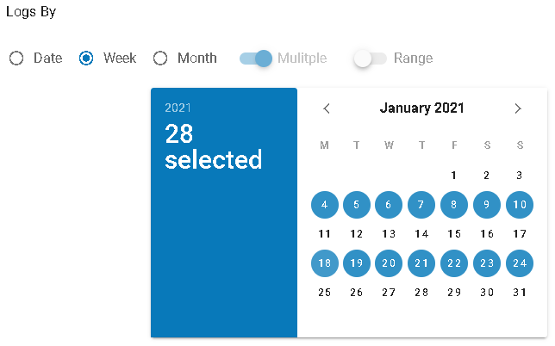

* Single month

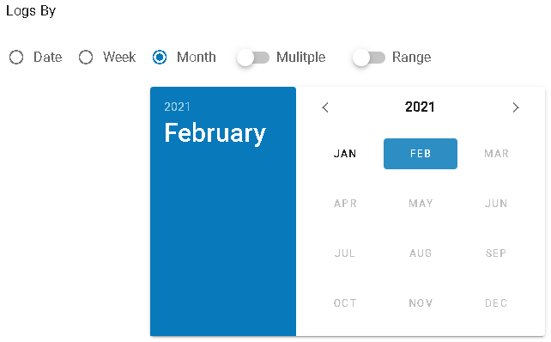

* Multiple months

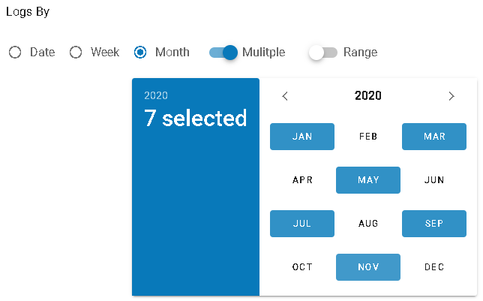

* Month range

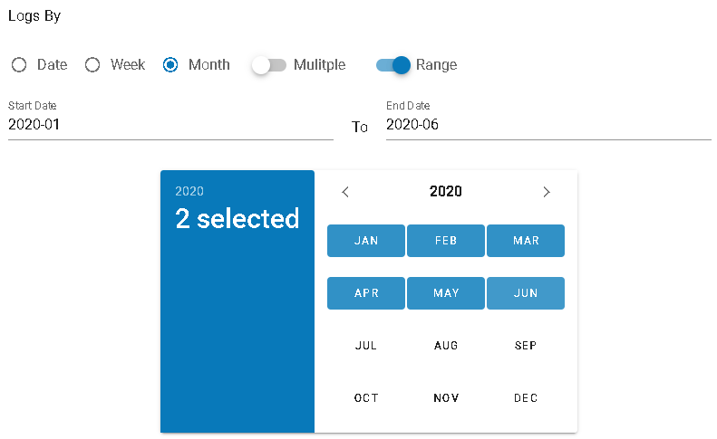

## Set source criteria

Time Box is integrated with many platforms three log time providers: 7pace by Azure Devops, Jira and time box itself.

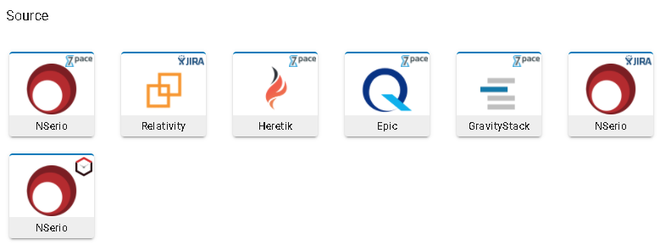

The user is able to select more than one source provider

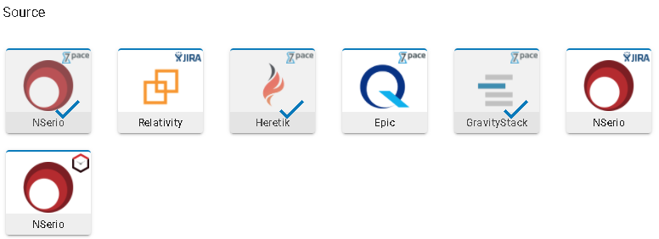

## Generate worklogs report

Once the user set the report criteria, he/she should click on  button and a csv file xlsx file will be downloaded.

